

School of Computing
Semester 2, 2023/24

Problem Solving Document
Data Structures and Algorithms
Lecturer: Emer Thornbury
Continuous Assessment 1
Created by: Alex Garbalyauskas: Student number: x22440482

Summary
Documentation of the problem solving done for the continuous assessment, showcasing starting sketches, class diagram, and summary of the interfaces, classes, methods, GUI and app used.

Initial Sketch Diagrams
Input Process Output sketch outlining initial brainstorming ideas at approaching the assessment.

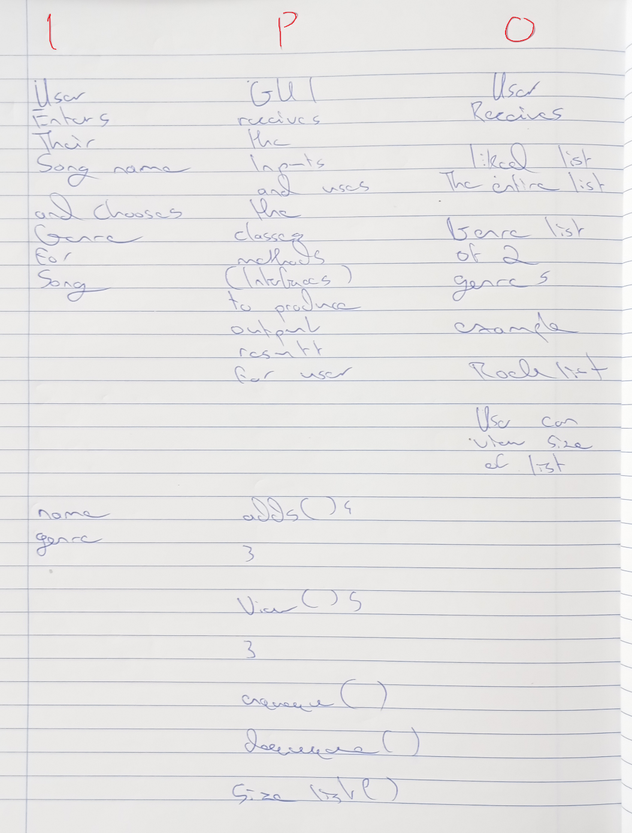

Simple Class sketch showcasing structure idea for the java application.

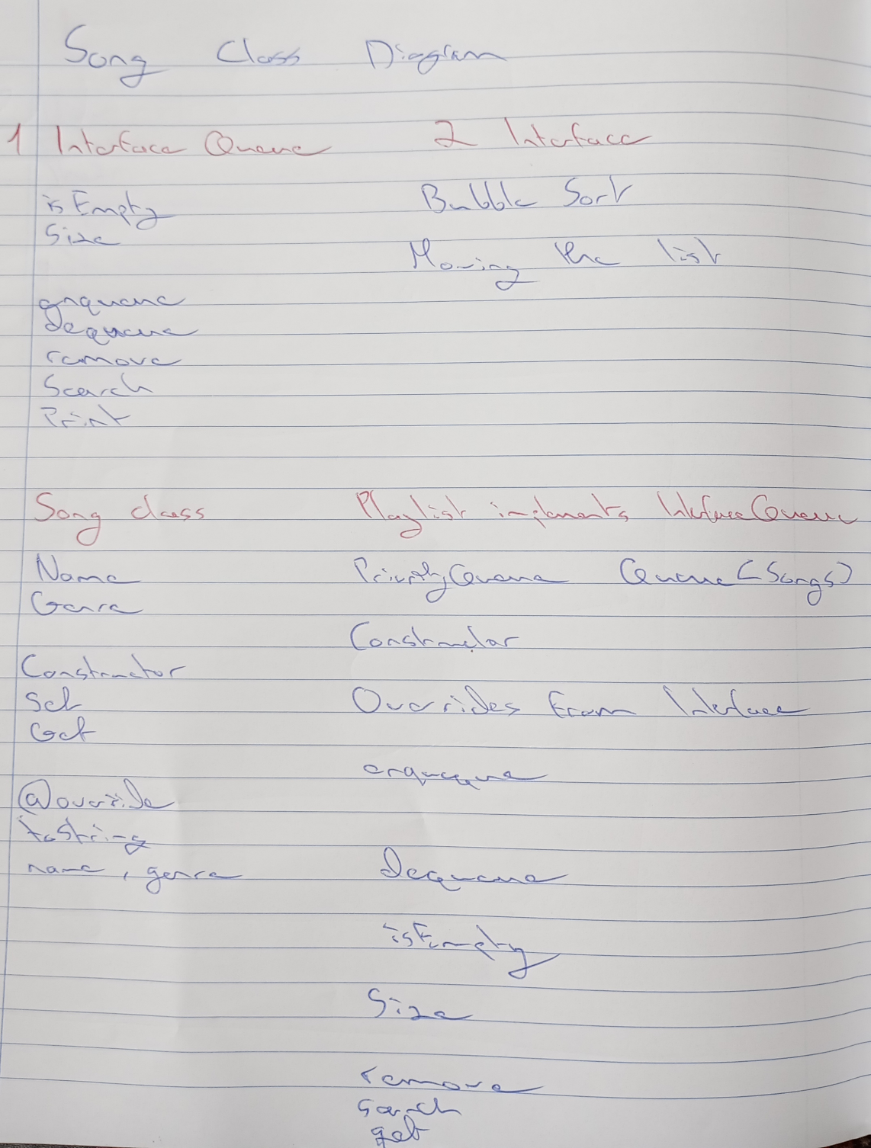

Class Diagram
Showcasing interfaces, classes, GUI, and app of application.

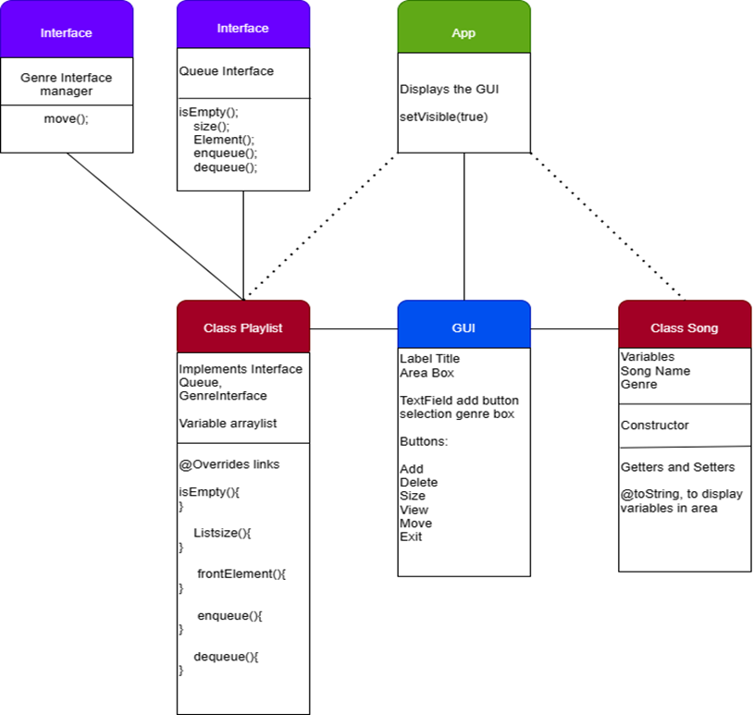

Summary Design
Abstract Data Types: Queue.

Interfaces:
Interface one is an interface that uses queue data managing methods for the playlist class that includes checking if the list is empty or not, the size of the list, adding the first element song to the list, adding song to the rear and front of the queue.
Interface two sets up move genre method, sorting the list.

Classes:
Song class initializes the song variables.
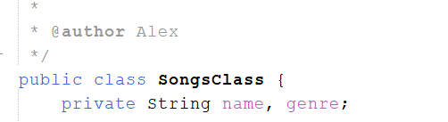
The variables allow user to input them within the graphic user interface. The class sets up the name and genre of the song sets them up, allows them to be retrieved and displayed using toString() method into the text area in GUI.
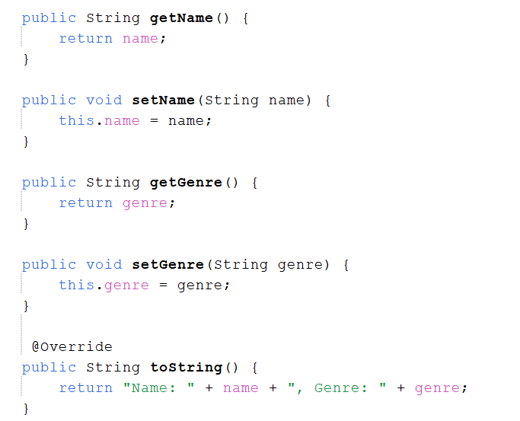

PlaylistQueue class implements both of the interfaces within itself. It sets up multiple array lists for each song list viewing option, the licked list and two of the genre lists.
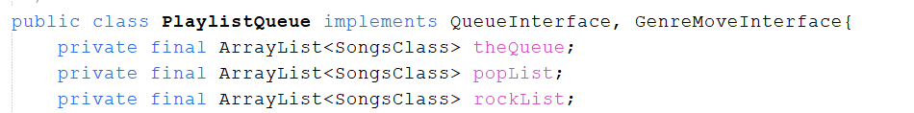
Since it implements the interfaces the managing methods have to be brought over using @Override. In this class the interface methods are coded in for functionality. isEmpty() method checks if the list is empty,
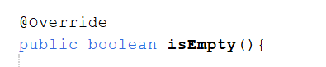
List size() returns the size of the licked list,
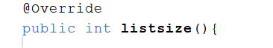
Front element() receives the first song at the start,
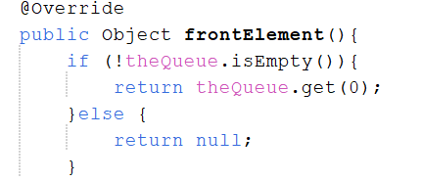
enqueue() adds a new song to the end of queue ,
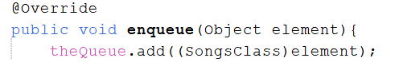
dequeue() removes and returns the song at the front,
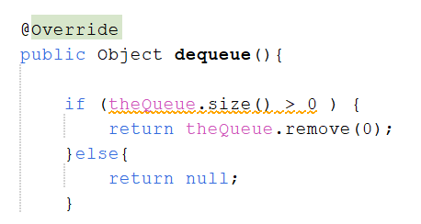
move() method moves the selected genre to its own list visible inside the text area,
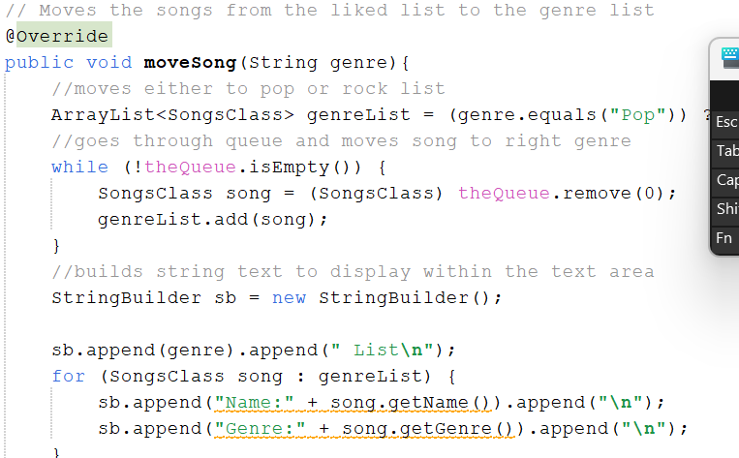
Not linked to the interfaces the display method helps displays the text of the inputted songs into the text area.
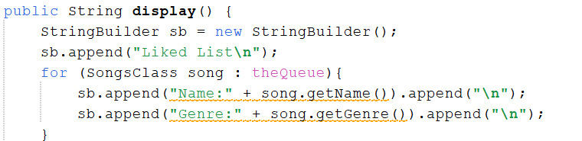
Search method.
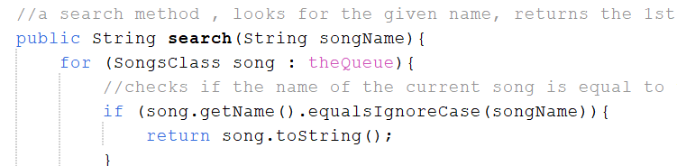
Has current song method makes sure the same song name not added.
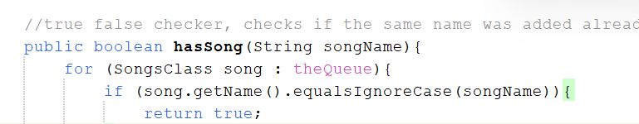

App:
Initializes the graphic user interface to be viewed by the user.
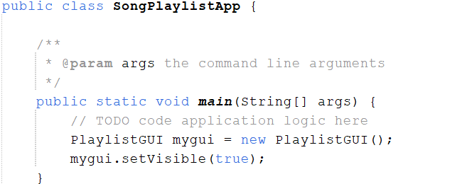

GUI:
Graphic User Interface Playlist links the playlist class by creating an instance variable.
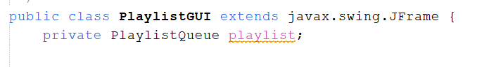
the playlist class helps manage the GUI button functions such as adding, viewing, searching, delete, size, and displaying the outputs inside the text area or as a JOption pop up message.

Add button gets inputs and tells user its added, no empty input or same names.
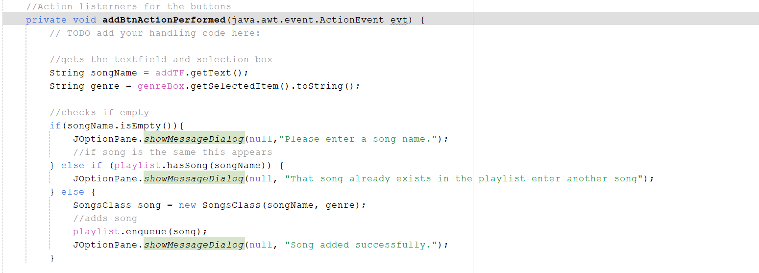

View button.
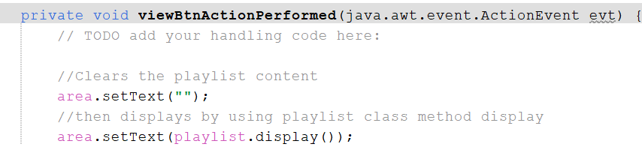

Exit button.
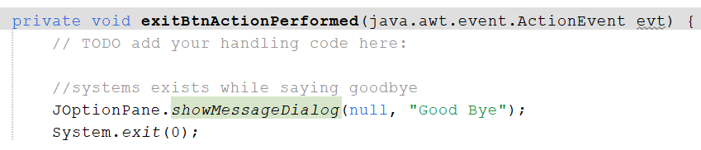

Search button.
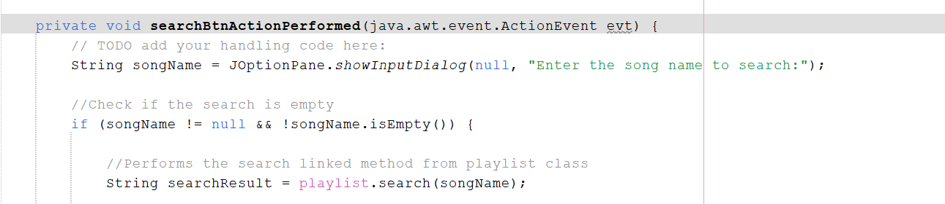

Delete button.
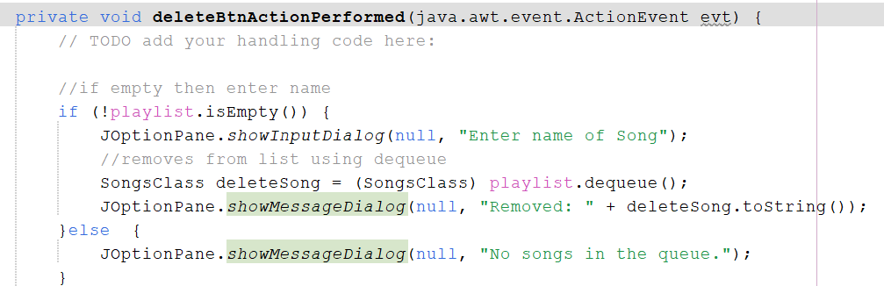

Size display button.
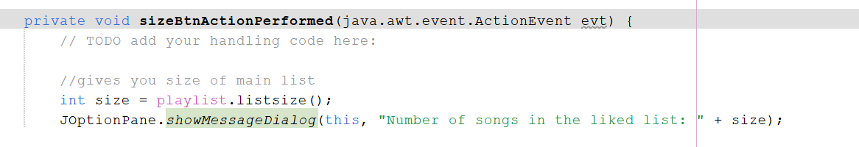

The GUI is designed appropriately to make it user friendly by using styling options of background change and icon images.

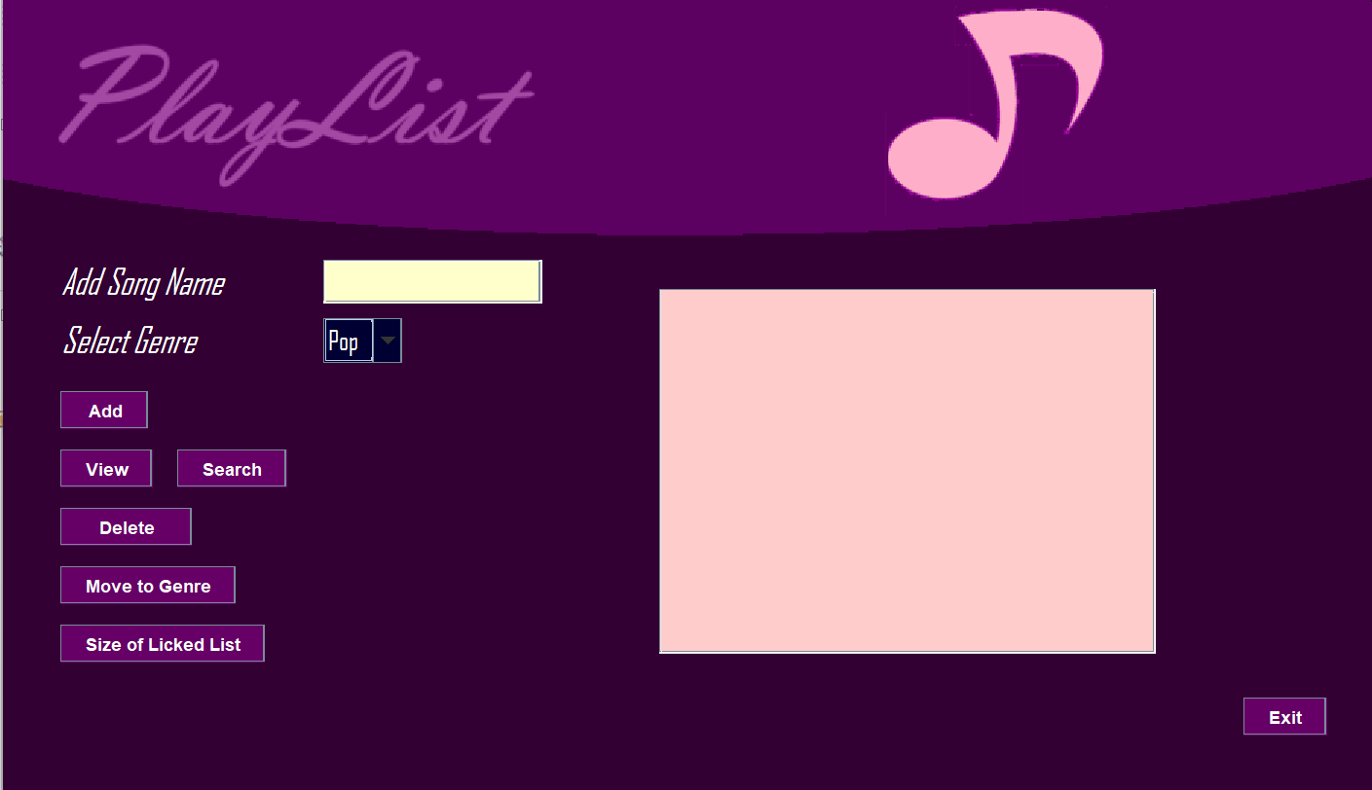

Github.com link
https://github.com/NCIAlexGar/Data-Structures-Algorithms-CA2/tree/main.

